**Class:** Final Year (Computer Science and Engineering)

**Year:** 2022-23 **Semester:** 1

**Course:** High Performance Computing Lab

**Practical No. 11**

**Exam Seat No:**

2019BTECS00051-Atharv Inamdar

**Title of practical:**

Analysis of MPI Programs

**Problem Statement 1:**

Execute the MPI program (Program A) with a fixed size broadcast. Plot the performance of the broadcast with varying numbers of processes (with constant message size). Explain the performance observed.

**Screenshot 1:**

#include <stdio.h>

#include <stdlib.h>

#include <time.h>

#include <mpi.h>

int main(int argc, char *argv*[]*)

{

    if (argc != 2)

    {

        printf("Usage : bcast message_size\n");

        return 1;

    }

    int rank;

    int size = atoi(argv[1]);

    char buffer[size];

    MPI_Init(&argc, &argv);

    MPI_Comm_rank(MPI_COMM_WORLD, &rank);

    int i;

    if (rank == 0)

    {

        srand(time(NULL));

        for (i = 0; i < size; i++)

            buffer[i] = rand() % 256;

    }

    double total_time = 0.0;

    double start_time = 0.0;

    for (i = 0; i < 100; i++)

    {

        MPI_Barrier(MPI_COMM_WORLD);

        start_time = MPI_Wtime();

        MPI_Bcast(buffer, size, MPI_CHAR, 0, MPI_COMM_WORLD);

        MPI_Barrier(MPI_COMM_WORLD);

        total_time += (MPI_Wtime() - start_time);

    }

    if (rank == 0)

    {

        printf("Average time for broadcast : %f secs\n", total_time / 100);

    }

}

**Screenshot 2:**

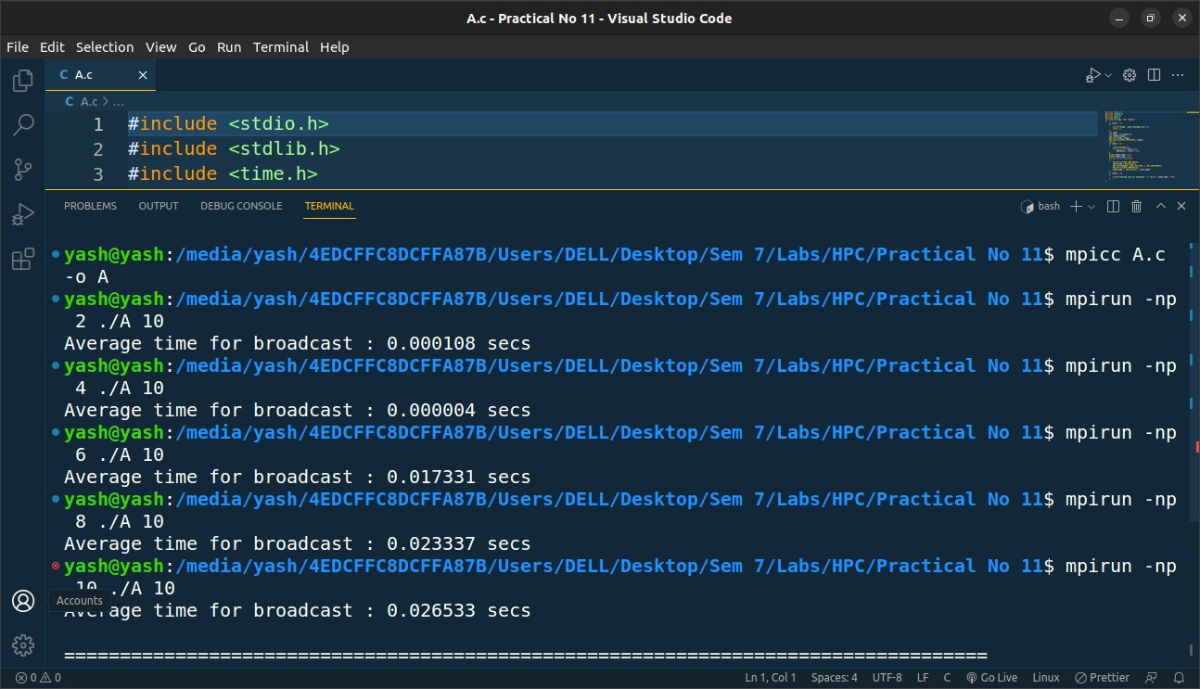

**Screenshot 3:**

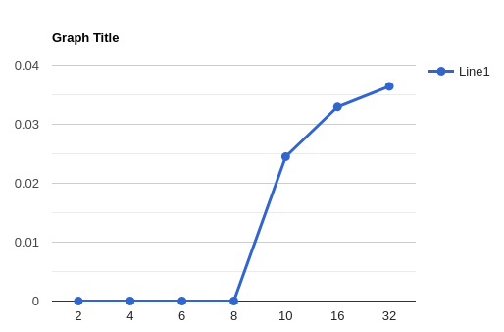

**Problem Statement 2:**

Repeat problem 2 above with varying message sizes for reduction (Program B). Explain the observed performance of the reduction operation.

**Screenshot 4:**

#include <stdio.h>

#include <stdlib.h>

#include <time.h>

#include <mpi.h>

int main(int argc, char *argv*[]*)

{

    if (argc != 2)

    {

        printf("Usage : reduce message_size\n");

        return 1;

    }

    int rank;

    int size = atoi(argv[1]);

    char input_buffer[size];

    char output_buffer[size];

    MPI_Init(&argc, &argv);

    MPI_Comm_rank(MPI_COMM_WORLD, &rank);

    int i;

    srand(time(NULL));

    for (i = 0; i < size; i++)

        input_buffer[i] = rand() % 256;

    double total_time = 0.0;

    double start_time = 0.0;

    for (i = 0; i < 100; i++)

    {

        MPI_Barrier(MPI_COMM_WORLD);

        start_time = MPI_Wtime();

        MPI_Reduce(input_buffer, output_buffer, size, MPI_BYTE, MPI_BOR, 0, MPI_COMM_WORLD);

        MPI_Barrier(MPI_COMM_WORLD);

        total_time += (MPI_Wtime() - start_time);

    }

    if (rank == 0)

    {

        printf("Average time for reduce : %f secs\n", total_time / 100);

    }

}

**Screenshot 5:**

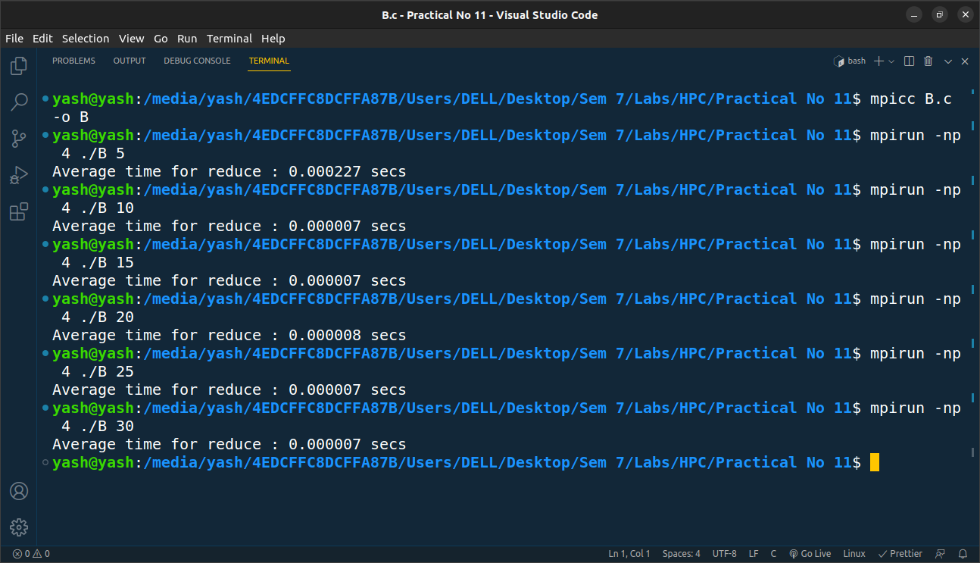

**Screenshot 6:**

